**CAMPALIN MACHINE LEARNING PROJECT**



SUBMITING BY

* Konishtha Sen

* Manne Chakradhar

* Import the required data libraries. Ex: Numpy, Pandas, Matplotlib, Seaborn, Scikit Learn
* Get the titanic dataset form Kaggle.

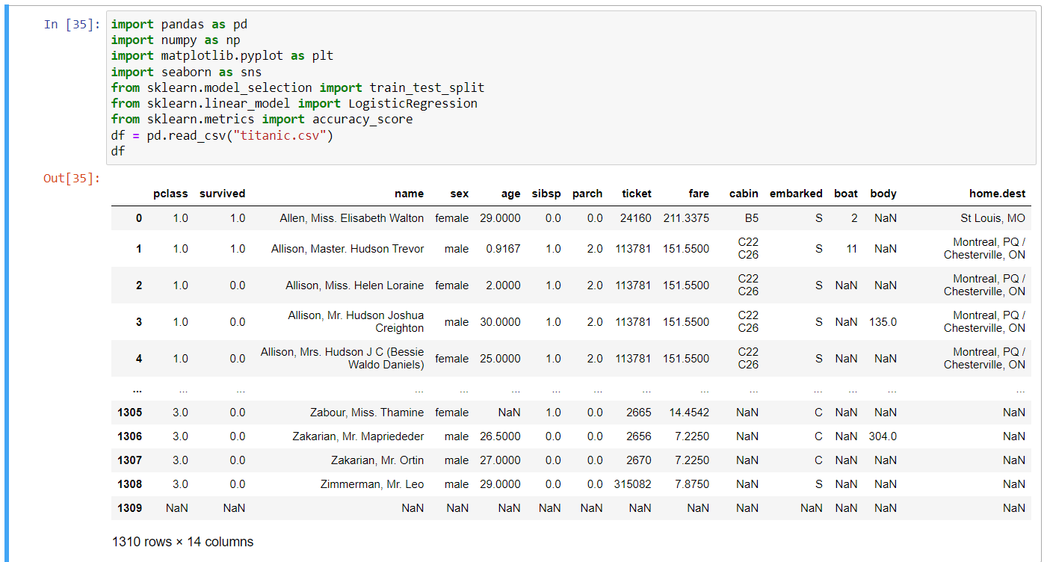

**Performing EDA (Exploratory Data Analysis**

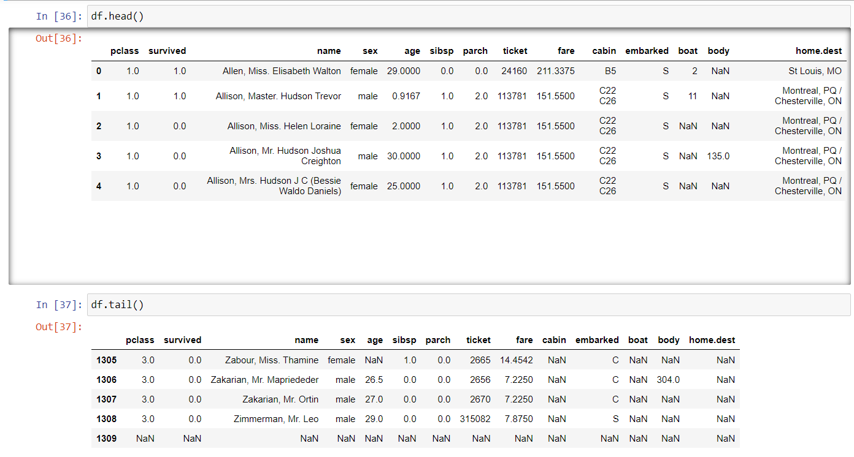

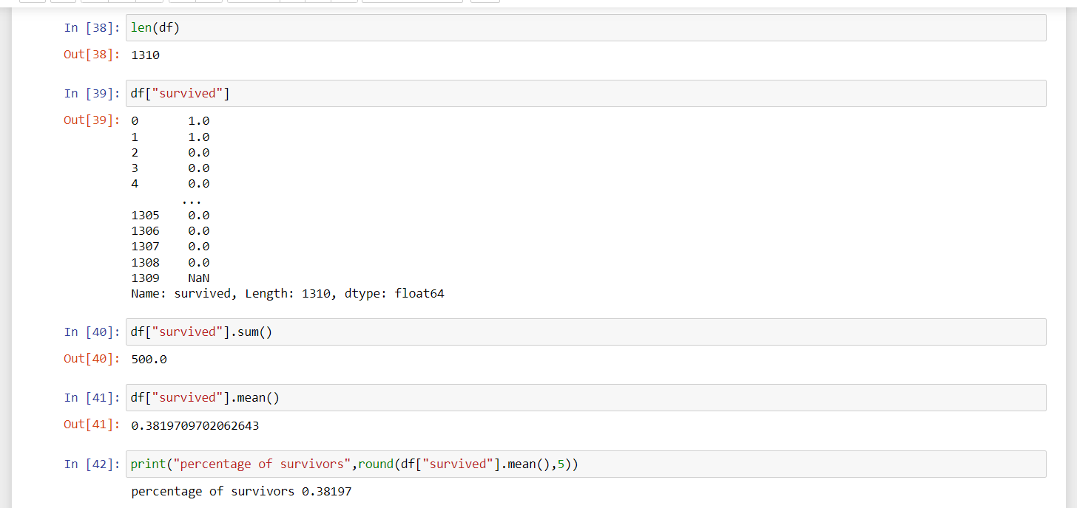

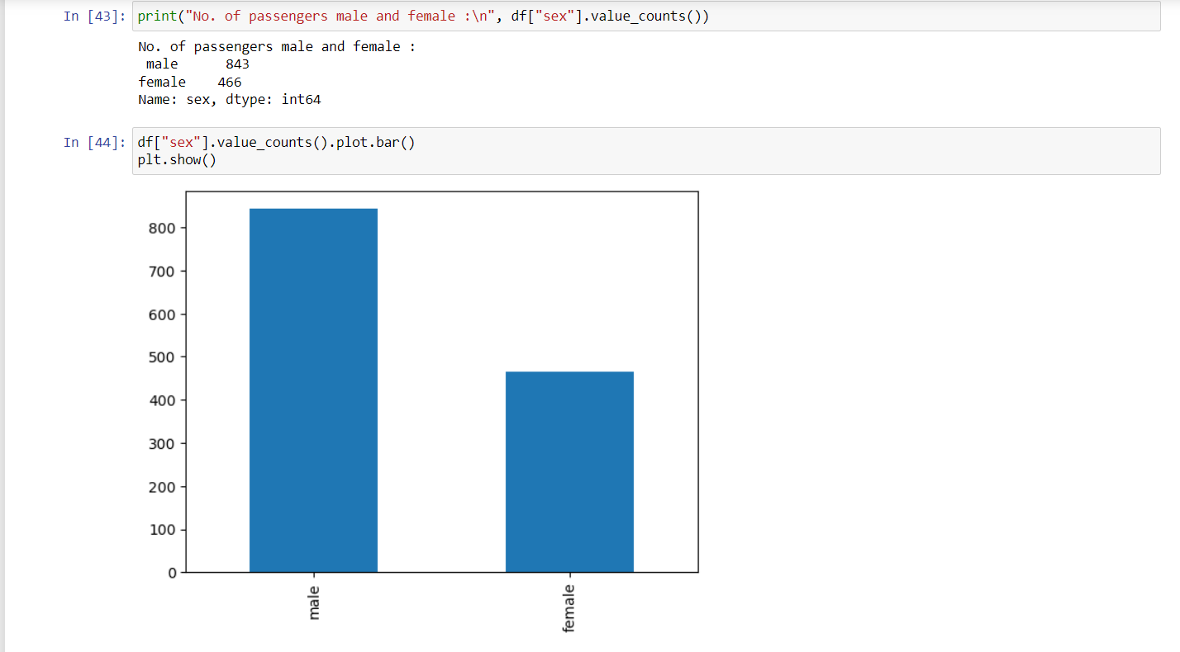

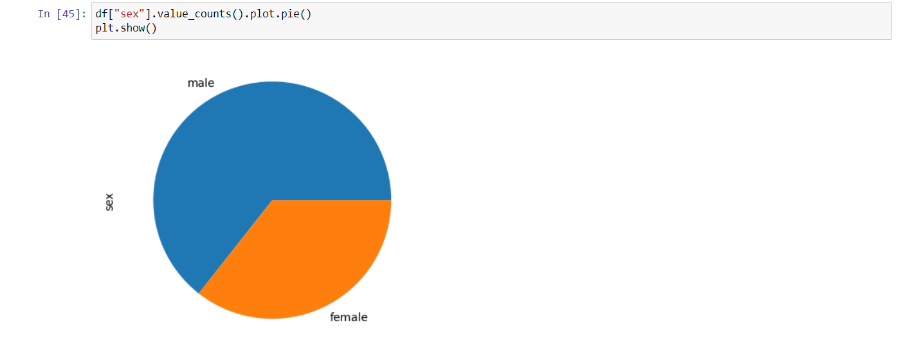

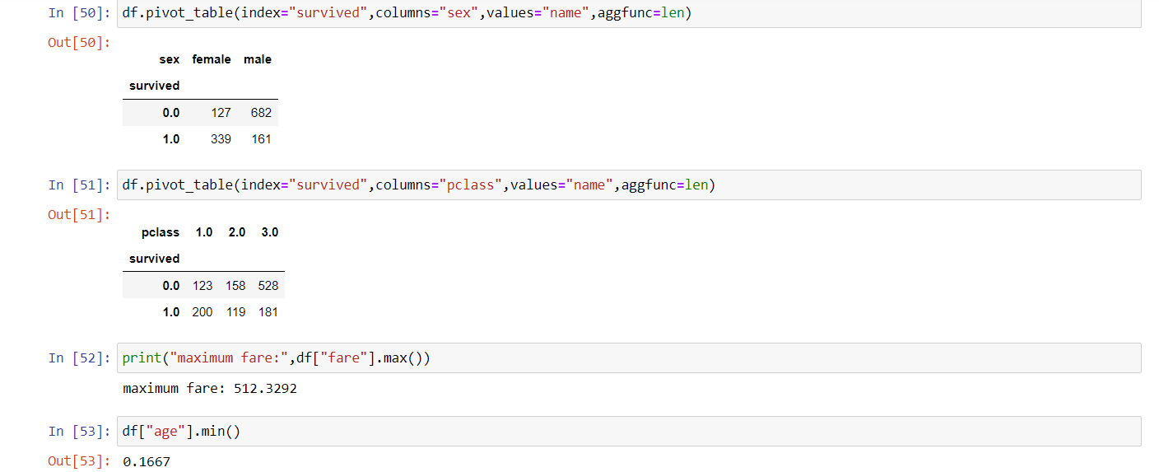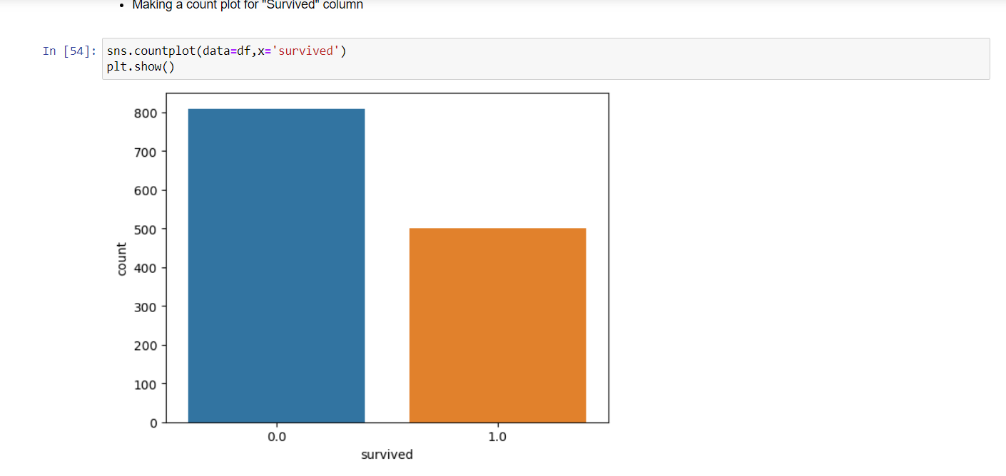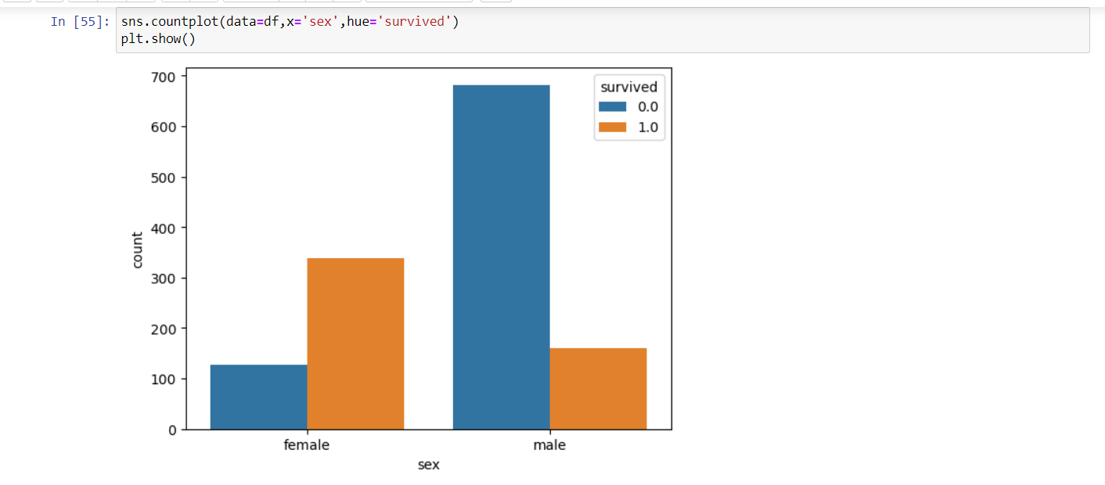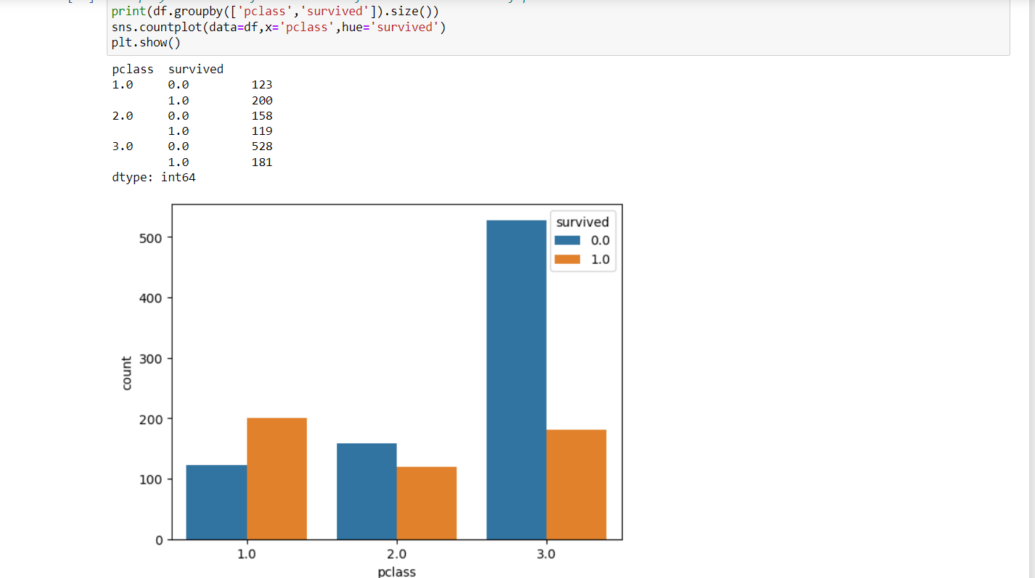

**BULIDING THE MODEL**

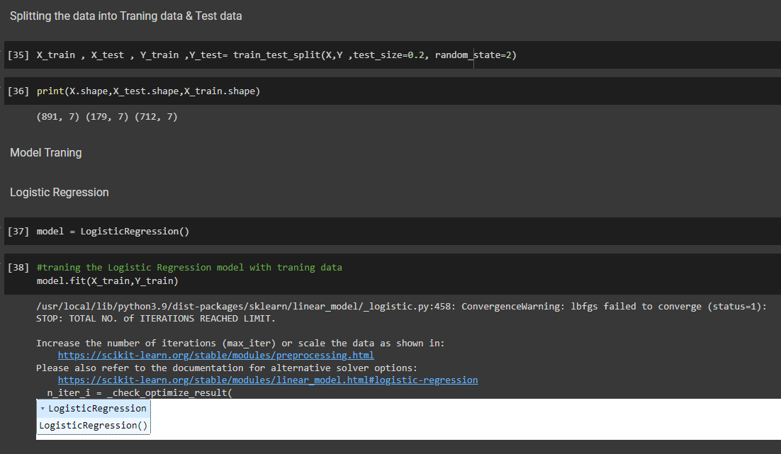

**TRAINING THE DATA**

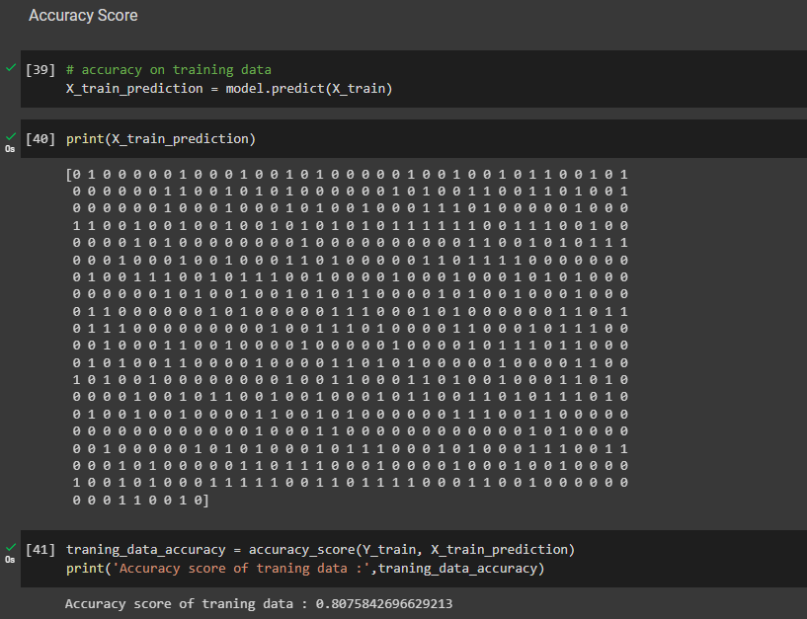

**PREDICTION AND ACCURACY: -**

**TEST DATA**

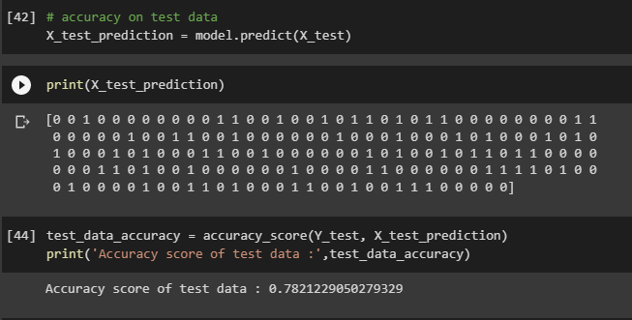

* **The Model predicts with an accuracy of 78%**